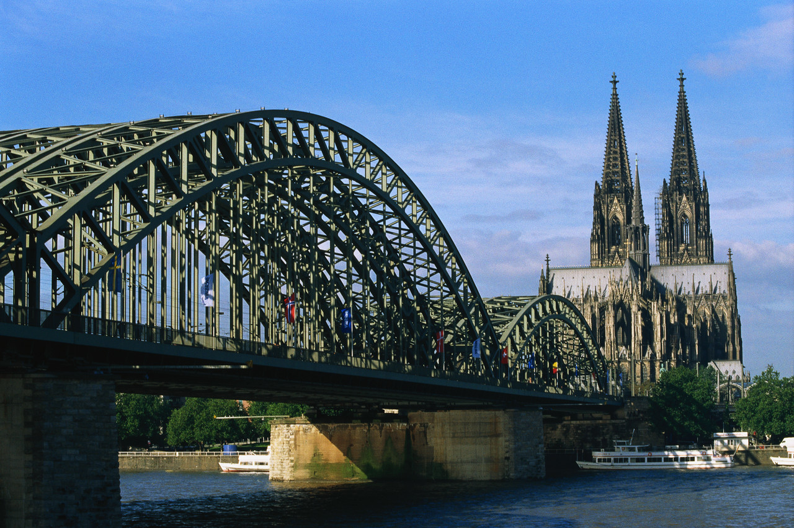
Sprachmittlungskompetenz
English as a World Language:
Creating a City Guide to Cologne
ein Unterrichtsmodul für die Jahrgangsstufe 9

Introduction
In this sequence we will create our own City Guide to Cologne.
You will have the chance to learn the following:
- describe a specific cultural event of your hometown to a foreigner
- strategies to mediate texts from one language to another
- mediate an English text into German and vice versa
- examine English city guides with regard to layout, structure, content and language
- write two articles about spots you like best in your city on the basis of internet research
- revise your own texts by checking them with the help of a partner and a checklist
- become aware of structural differences between English and German (word order, sentence structure)

Tasks:

M1
Imagine your American pen pal Jim is planning to visit you in Cologne. He is preparing his trip with the help of the internet and has come across these pictures. Now he asks you what these people are doing and why. Write him an email telling him about Karneval in Cologne. What can he see in the pictures? What else would you like to tell him about this time of the year? Comment on the way Karneval is celebrated in your city, in school, at home…

 hier bitte Bilder vom Kölner Karneval selbst ergänzen

M2
Some days later you get an email from Jim. He still has a couple of questions because he could not understand some of the word you used in your email. Please write an answer explaining what the underlined words mean with the help of the support system!

- We were walking along the street when we met the “Rosenmontagszug”.
- Every year, in Cologne, we have a big celebration, which is called “Karneval”.
- They make big “Züge” where they play music and throw sweets.
- It is a festival before the “Fastenzeit”.
- And at the end some “nubbels” are thrown into the fire.

(Beispiele veränderbar, je nach Lerngruppe!)

Support system (1):
Paraphrasing difficult words

- Describe the words you don’t know:
Kölnisch Wasser → It’s a special perfume which is only produced in Cologne.

- Choose a general term for a special one:
Verkehrsregeln → rules

- Choose words of the everyday language for more elaborate ones:
Besucher nehmen die kleine Kirche nicht wahr. → Visitors don’t see the little church.

M3
Für die Schülerzeitung sollen Du und Dein Partner einen Beitrag über Shopping in den USA schreiben. Du bittest Jim um Informationen, und er schickt Dir folgenden Text. Fasst die wichtigsten Informationen des Textes in einem kurzen Artikel zusammen! Die beiliegende Anleitung kann Euch dabei helfen.

Shopping in the US

The big shopping malls are in the suburbs
There are still some department stores and downtown shopping areas in most US cities, but the big shopping malls and discount stores are usually located out in the suburban communities. Some of the major outlet centers are located in the countryside miles from the nearest major city. It is best to have an automobile if you want to do any serious bargain shopping.
Department stores offer good quality and high fashion
Department stores are large establishments that offer a wide selection of merchandise including fashion clothing, house wares, appliances, luggage and jewelry. They normally offer good quality merchandise, well known brands and the latest fashions, but not low quality products at bargain prices. […]
The big department stores are typically parts of national chains, so you can find the same stores in many cities. They normally have a downtown store in a major city with several branch stores in the surrounding suburban shopping malls. Here are the names of some well-known national department stores: Lord & Taylor, Macy's, Bloomingdale's, Marshall's and Bergdorf-Goodman.

State and local sales taxes can be confusing
The US government does not levy a value-added tax on merchandise as governments do in many other countries, but most states and some cities collect a sales tax on all purchases. State taxes usually average 4% to 8%. Some cities add an additional 2%. Remember when you purchase something for $1.00, you may have to pay $1.08. Some states exempt all clothing and food purchases from sales tax.
http://www.usatourist.com/english/tips/Shopping2.html

Support system (2):
Mediating a written text

- Identify the bits of information your communication partner needs to know
  - Highlight crucial passages in the text (Who? What? When? Where? Why? How?).
  - Delete information that is irrelevant.

- Mark difficult parts of the text
  - Underline words you don’t know and look them up in the dictionary.
  - Paraphrase parts of the text.
  - Reformulate passages more simply. Replace technical terms by words that are part of everyday language.

- Present information to your partner
  - Select the information you want to mediate. Leave out information that is not needed.
  - Change the order in which information is given if this helps understanding.
  - Explain technical jargon.
  - Add information on the cultural background if necessary.
M4
Jim is curious about the shopping habits in Germany. He has heard that the opening hours are very different to what he is used to. Inform him about opening hours in Germany. Take the following text as the basis of your explanation.
Öffnungszeiten
Die Öffnungszeiten sind im europäischen Vergleich sehr unpraktisch, insbesondere wenn man in Deutschland einem Beruf nachgeht. Für Touristen sind die Öffnungszeiten irrelevant, da man in der Regel mit freier Zeit kommt. Geschäfte öffnen in Deutschland Montags bis Samstags von 6 bis 20 Uhr, in einigen Bundesländern auch darüber hinaus. In größeren Städten und generell bei großen Handelsketten wird zumindest in den Abendstunden diese Regelung voll ausgeschöpft. Kleinere Einzelhandelsgeschäfte haben jedoch meist nur bis 18 oder 19 Uhr geöffnet, samstags wird bereits am späten Mittag geschlossen (Immer mehr Geschäfte, wie z.B. Lebensmittelketten haben aber auch hier bis 20 Uhr geöffnet). Friseursalons sind montags meist geschlossen. Gänzlich vom Ladenschluss ausgenommen sind Friseurgeschäfte, Tankstellen sowie Geschäfte in Bahnhöfen, auf Flughäfen und in Kurorten - hier ist allerdings mit deutlich höheren Preisen zu rechnen. Weiterhin dürfen Bäckereien, obwohl sonst an die genannten Zeiten gebunden, Sonntag Vormittags Kuchen und Brötchen verkaufen. Pro Stadt gibt es außerdem 4 verkaufsoffene Sonntage pro Jahr.
Seit dem 01.12.2006 haben einige Bundesländer bereits eine völlige Freigabe der Zeiten (mit Ausnahme des Sonntags) gestattet, zum Beispiel in Berlin, Brandenburg und Hamburg.
http://wikitravel.org/de/Deutschland#Einkaufen
M5
Language Awareness: Fehleranalyse von SuS-Arbeiten (z.B. einseitige Verwendung von Adjektiven, Satzbau, Satzlänge…), Bewusstmachung der Probleme anhand der eigenen Beispiele

M6
Exchange your texts with a partner and correct your partner’s text with the help of the checklist!
Support system (3):
Language checklist

aspect | questions to ask when correcting a text
tense | Is the text written in the present tense (3rd person –s)?
sentence structure | Are the sentences rather short and clearly presented?
word order | Is the word order correct (S-P-O-Pl-T)?
word choice | Does the text paraphrase special cultural terms? Does the text contain a variety of suitable adjectives?
spelling | Are all names of sights or time data (days, months) capitalized?

M 7
Getting ideas from English city guides
Look at this English City Guide and collect ideas for your own guide from this example and present it to the other members of your class. Here are some aspects you could pay attention to:
- How’s the front page designed?
- What does it start with?
- How’s the list of content designed?
- Is the guide divided into different parts? What are they called?
- What are these parts about?
- What is given in an extra part at the end? What of this could be useful to us?
- How are the actual topics, facts, tips etc. presented? → layout, content, length, order…
- Try to describe the language they use in the guide. Is there anything special to it?
- Give short examples of texts written in a style you like.
Pay special attention to things that you really like. How can you use them for our own guide?

M8
Creating a City Guide
Let’s write a city guide for young visitors from abroad! Write two articles about two spots you like best in your city (restaurants, shopping places, bars, sights…)! Get all information a foreigner needs when visiting these places from a German website.

Revise your article with the help of the following support systems.
- Paraphrasing difficult words
- Mediating a written text
- Checklist

