Aufgabenbeispiel

Semester 3, 2. Quartal, Einheit 2

On aging

Love for life, Semester 3, 2. Quartal, Einheit 2

Lots of people have different views on being old, middle-aged or young. In this unit you will work on how the topic of aging is treated in literature.

1. Speaking – How old is old?

- Have a look at the following picture.
- Exchange your thoughts and feelings on the picture in small groups.

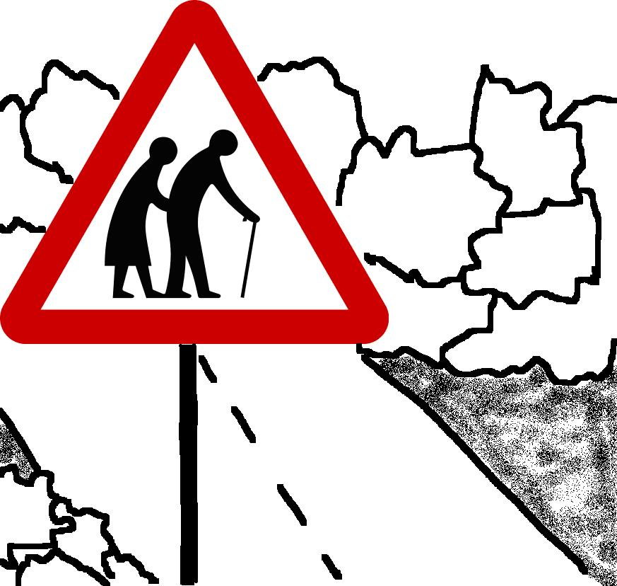
Quelle: http://commons.wikimedia.org/wiki/File:Singapore_Road_Signs_-_Warning_Sign_-_Elderly_or_Blind_People.svg;
Bild überarbeitet

2. Speaking – Pictures say more than thousand words
Let’s have a closer look on "elderly" people and "aging".
Work with a partner.
1. Enter the term "elderly people" into your favourite search engine and choose pictures which show elderly people.
2. What ideas of "elderly people“ are presented in the pictures? Choose at least 4 pictures which show different aspects of "aging“.
3. Structure these aspects with the help of a mind map. The mind map in doc 1 starts you off with some ideas.
4. Be prepared to present your findings to the rest of the class.

Doc 1 – Mind map

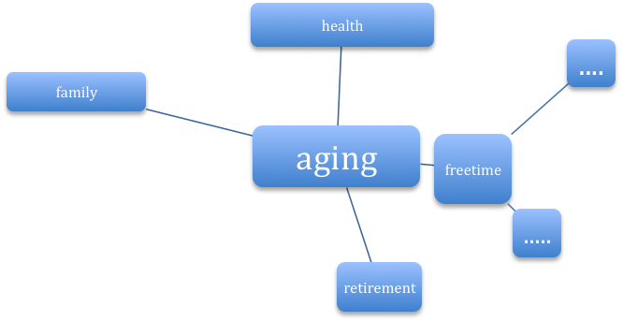

3. Speaking – Discussion

Discuss: How do you think elderly people want to be treated?

4. Reading – Maya Angelou: On aging

1. Get a copy of the poem On aging by Maya Angelou.
2. Read the poem and answer the following questions:
- Who is talking?
- What aspects of "aging" are presented in the poem?
3. Compare the aspects on “aging” with the ones of your mind map. If necessary, add aspects that are missing.

5. Analysing a poem – Maya Angelou: On aging

Work with a partner.
1. Underline expressions in the poem …
- that show what the aging person in the poem thinks of herself/himself.
- that show how the aging person in the poem does not want to be treated by others.
2. Write your results down in a grid (Doc 2)

Doc 2 – Grid

The speaker in the poem thinks:
I am a person who … | Other people think that I …
- … | - …
- … | - …
- … | - …

6. Speaking – Reciting the poem

The way one reads out a piece of literature shows how one understands it. Prepare your very personal recital of Maya Angelou’s poem “On aging”.

Proceed as follows:
1. Work in small groups.
2. Discuss what message the narrator of the poem wants to express.
3. How is the message supported? To answer the question, have a look at the language the author uses. Find examples (e.g. choice of words, contrasts, sentence constructions) and show how they underline the message.
4. In your groups: Practice reading out the poem. Make sure your reading supports the message of the poem.
5. Be prepared to recite your poem to the class.

7. Writing – Writing a letter

Maya Angelou once said that “people never forget how you made them feel”.

- Write a letter to Maya Angelou in which you express your opinion on how she treats the theme of “aging” in her poem.
- You want to make a good impression, so plan your letter well. Proceed as follows:
- Note down what aspects you would like to write about in your letter.
- Write a first draft of your letter.
- Check your first draft of the letter with the help of the criteria in Doc 3.
- Write your final version of your letter to Maya Angelou.

Doc 3 – Criteria for good letter writing

 | Check ☑
- Formal correctness:  date and form of address, ending  - Introductory paragraph:  your person, your reason for your letter, your intention of writing the letter  - Structure:  clear presentation of your thoughts,  logical and clear structure  ( use of connectives; new paragraphs for new ideas)  - Language:  formal English  polite language  - Correctness:  spelling, grammar, choice of words | ☐  ☐  ☐  ☐  ☐  ☐

